**PATUAKHALI SCIENCE AND TECHNOLOGY UNIVERSITY**

**COURSE CODE CCE-122**

**SUBMITTED TO:**

### **Prof. Dr. Md Samsuzzaman**

### **Department of Computer and Communication Engineering**

**Faculty of Computer Science and Engineering**

**SUBMITTED BY:**

**Md. Sharafat Karim**

ID: **2102024**,

Registration No: **10151**

**Faculty of Computer Science and Engineering**

Date of submission: **6 September, 2023**

Assignment: Lab Problem 1

Assignment title: Java compile and IDE

## 1.Write the assignment based on how to compile and run java program using command prompt.

**Ans:**

To compile and run a java program, first we have to make sure to install a java development kid or JDK in short. It can be downloaded from the official website.

<https://www.oracle.com/java/technologies/downloads/>

Here we can download according to our operating system. I’m using a Linux based operating system Arch Linux. For most of the Linux distributions, JDK comes preinstalled. Or we can also download the binary from the above website.

After setting up our JDK, we have to make sure that, javac and other binary files are in our path environment variable. In linux, I can type “env | grep “PATH”” to list all of my environment variables. After PATH is set, we can check either it’s properly working or not. We can verify it by running, “javac –version”  
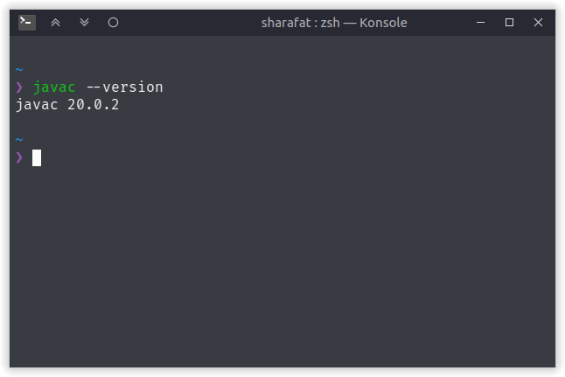

Afterwards, I’ll go to a directory and create an empty file and write a java program on it with a main method.  
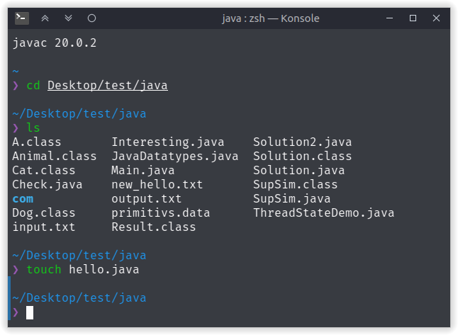  
 Now I’ll use a text editor to write a simple java program. Here I’m using terminal based text editor, nano.

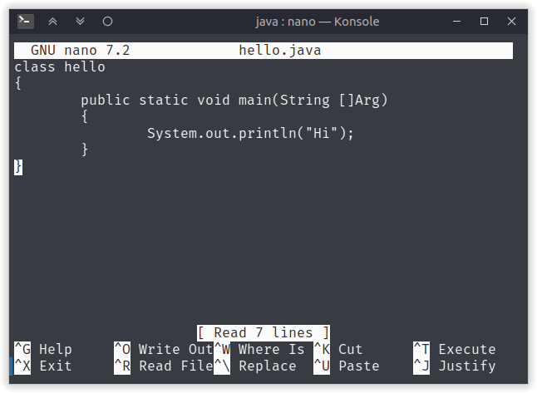  
Later we can compile this file using javac command.

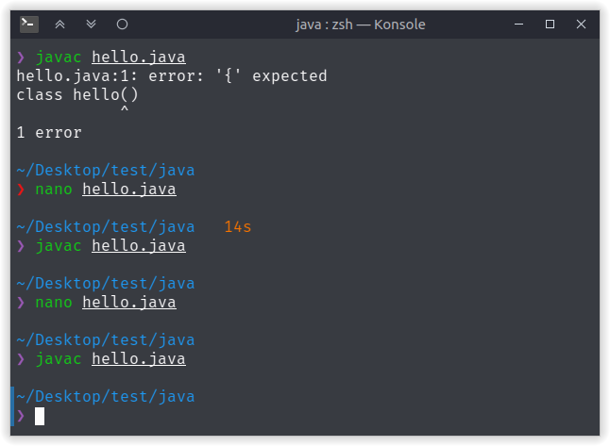And, finally we can run the file using java class_name command

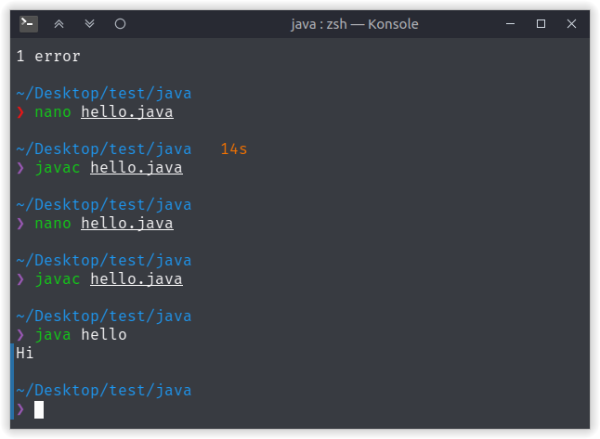

## 2. Write step by step for compiling and run java program through IDE like Netbeans, IDEAJ eclipse etc.

**Ans:**

To run a program from an IDE, first we have to install it. For netbeans, first we have to go to it’s official website. Then there is a download on the top right part. There we can download binary for different operating systems. As I’m running linux, I can use my systems package manager to install it.

After installing, we can open netbeans. There I can create a new project from the File and then New project button. On that page we can select Java application. Then we can specify our application name and other details. Afterwards, we can create a new class. With that class, we will get a default template set. After writing our code, we can compile it and run it with right click and pressing run code.

For IDEAJ we have to use the official web we can download the client according to our operating system. I’m using Linux so I’ll pick tar archive and install it.

Then I will create a new new project by specifying my project name and other information. Later I’ll create a simple java program. To run the code there is a run button on the top right corner. Or, we can use the shortcut ctrl + F10.

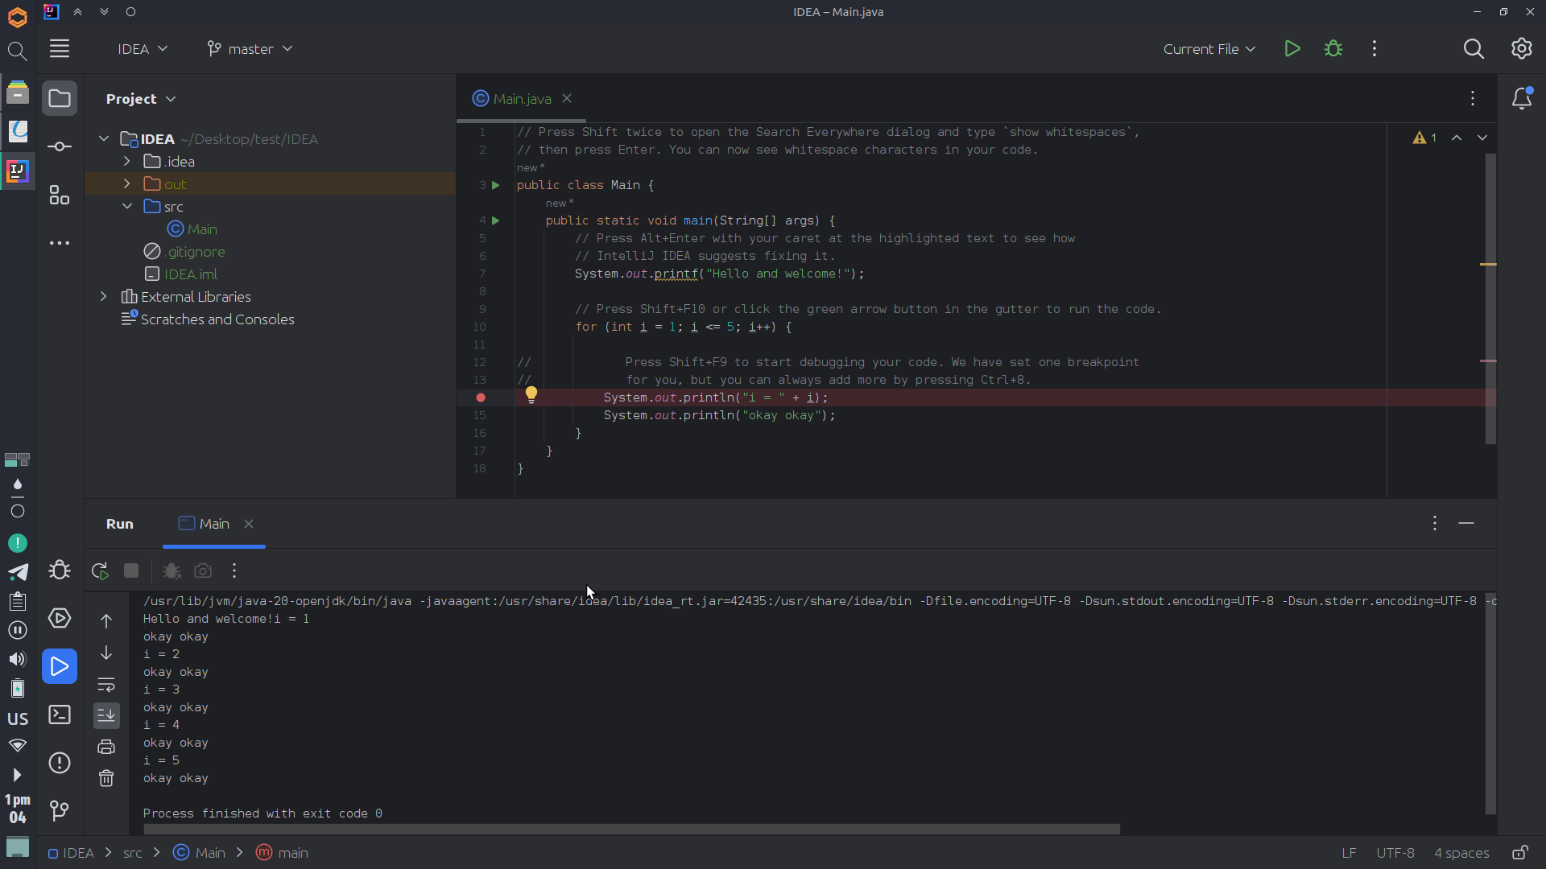

For eclipse, we can follow same procedure. After creating a new class inside a project we can simply use run button to run the code.

As an alternative we can also use visual studio code to run java codes.